Higher Nationals - Summative Assignment Feedback Form

|  |  |  |  |  |  |
| --- | --- | --- | --- | --- | --- |
|  | | | | | |
|  |  |  |  |  |  |
|  | | | | | |
|  |  |  |  |  |  |
|  | | | | | |
|  |  |  |  |  |  |
|  | | | | | |
|  |  |  |  |  |  |

|  |  |  |  |
| --- | --- | --- | --- |
| **Student Name/ID** |  | | |
| **Unit Title** | **47: Emerging Technologies** | | |
| **Assignment Number** |  | **Assessor** |  |
| **Submission Date** |  | **Date Received 1st submission** |  |
| **Re-submission Date** |  | **Date Received 2nd submission** |  |
| **Assessor Feedback:**  **LO1** Review which emerging technologies are necessary and appropriate when designing software applications for the future  **Pass, Merit & Distinction P1 P2 M1 M2 D1 Descripts**  **LO2** Research an emerging technology and its impact on a given end-user group  **Pass, Merit & Distinction P3 M3 Descripts**  **LO3** Develop multiple iterations of an emerging technology solution based on requirements.  **Pass, Merit & Distinction P4 M4 D2 Descripts**  **LO4** Consider the ethical, social, economic, and legal factors that play a role in the success of emerging technologies.  **Pass, Merit & Distinction P5 M5 D3 Descripts** | | | |

Please note that grade decisions are provisional. They are only confirmed once internal and external moderation has taken place and grades decisions have been agreed at the assessment board.

|  |  |  |
| --- | --- | --- |
| **Assessor Feedback:**  *Please note that constructive and useful feedback should allow students to understand:   1. Strengths of performance 2. Limitations of performance 3. Any improvements needed in future assessments   Feedback should be against the learning outcomes and assessment criteria to help students understand how these inform the process of judging the overall grade.  Feedback should give full guidance to the students on how they have met the learning outcomes and assessment criteria. | | |
| **Grade:** | **Assessor Signature:** | **Date:** |
| **Resubmission Feedback:**  *Please note resubmission feedback is focused only on the resubmitted work | | |
| **Grade:** | **Assessor Signature:** | **Date:** |
| **Internal Verifier’s Comments:** | | |
| **Signature & Date:** | | |

**Pearson Higher Nationals in**

Computing

47: Emerging Technologies

Assignment 01 of 01

**General Guidelines**

1. A Cover page or title page – You should always attach a title page to your assignment. Use the previous page as your cover sheet and make sure all the details are accurately filled.
2. Attach this brief as the first section of your assignment.
3. All the assignments should be prepared using word processing software.
4. All the assignments should be printed on A4-sized papers. Use single-sided printing.
5. Allow 1” for the top, bottom, and right margins and 1.25” for the left margin of each page.

**Word Processing Rules**

1. The font size should be **12** points and should be in the style of **Time New Roman**.
2. **Use 1.5 line spacing**. Left justify all paragraphs.
3. Ensure that all the headings are consistent in terms of font size and font style.
4. Use the **footer function in the word processor to insert Your Name, Subject, Assignment No, and Page Number on each pag**e. This is useful if individual sheets become detached for any reason.
5. Use word processing applications spell check and grammar check functions to help edit your assignment.

**Important Points:**

1. It is strictly prohibited to use textboxes to add texts to assignments, except for compulsory information. eg: Figures, tables of comparison, etc. Adding text boxes to the body except for the before mentioned compulsory information will result in the rejection of your work.
2. Avoid using page borders in your assignment body.
3. Carefully check the hand-in date and the instructions given in the assignment. Late submissions will not be accepted.
4. Ensure that you give yourself enough time to complete the assignment by the due date.
5. Excuses of any nature will not be accepted for failure to hand in the work on time.
6. You must take responsibility for managing your own time effectively.
7. If you are unable to hand in your assignment on time and have valid reasons such as illness, you may apply (in writing) for an extension.
8. Failure to achieve at least PASS criteria will result in a REFERRAL grade.
9. Non-submission of work without valid reasons will lead to an automatic RE FERRAL. You will then be asked to complete an alternative assignment.
10. If you use other people’s work or ideas in your assignment, reference them properly using the HARVARD referencing system to avoid plagiarism. You have to provide both in-text citations and a reference list.
11. If you are proven to be guilty of plagiarism or any academic misconduct, your grade could be reduced to A REFERRAL, or at worst you could be expelled from the course.

STUDENT ASSESSMENT SUBMISSION AND DECLARATION

When submitting evidence for assessment, each student must sign a declaration confirming that the work is their own.

|  |  |  |  |
| --- | --- | --- | --- |
| Student name: | | Assessor name: | |
| Issue date: | Submission date: | | Submitted on: |
| Programme: **Emerging Technologies** | | | |
| Unit: **47:** | | | |
| Assignment number and title: 01 - **Expo Technologies - ET & the Future** | | | |

Plagiarism

Plagiarism is a particular form of cheating. Plagiarism must be avoided at all costs and students who break the rules, however innocently, may be penalized. It is your responsibility to ensure that you understand correct referencing practices. As a university-level student, you are expected to use appropriate references throughout and keep carefully detailed notes of all your sources of materials for material you have used in your work, including any material downloaded from the Internet. Please consult the relevant unit lecturer or your course tutor if you need any further advice.

**Guidelines for incorporating AI-generated content into assignments:**

The use of AI-generated tools to enhance intellectual development is permitted; nevertheless, submitted work must be original. It is not acceptable to pass off AI-generated work as your own.

**Student Declaration**

**Student declaration**

I certify that the assignment submission is entirely my own work and I fully understand the consequences of plagiarism. I understand that making a false declaration is a form of malpractice.

**Higher National Diploma in Business**

Assignment Brief

|  |  |
| --- | --- |
| Student Name /ID Number |  |
| **Unit Number and Title** | **47: Emerging Technologies** |
| Academic Year |  |
| Unit Tutor |  |
| **Assignment Title** | **Expo Technologies - ET & the Future** |
| Issue Date |  |
| Submission Date |  |
| IV Name & Date |  |

|  |
| --- |
| **Submission format** |
| **Submission for this assignment should be a report and a 15-minute presentation.**  **Presentation** - For your presentation, you will be expected to utilize appropriate tools  (PowerPoint, etc.) and include support material such as wireframes, diagrams, sketches, user interviews, etc. where appropriate. |

**Research Report** - as a part of the research conducted, develop a research report using research

data gathered about your chosen Emerging Technology, industry, and end user.

Final Report – Arrange all your answers in a professionally written report that includes.

1. Research report as a part of the research conducted.
2. Presentation slides and speaker notes of a 15-minute Presentation – Arrange a presentation to demonstrate your findings, gather feedback, and answer questions.

c. Evaluation

of

the

Emerging

technologies

For the final report and the research report, you are expected to make use of appropriate

structure – including headings, paragraphs, subsections, and illustrations as appropriate and all work must be supported with research and referenced using the Harvard referencing system.

|  |  |
| --- | --- |
|  | **Unit Learning Outcomes:** |
|  | LO1 Review which emerging technologies are necessary and appropriate when designing software applications for the future.  LO2 Research an emerging technology and its impact on a given end-user group.  LO3 Develop multiple iterations of an emerging technology solution based on requirements LO4 Consider the ethical, social, economic, and legal factors that play a role in the success of emerging technologies |

|  |  |
| --- | --- |
|  | **Assignment Brief and Guidance:** |
|  | **Scenario**  ***'Expo Technologies '*** is a renowned research and consulting organization that focuses on emerging technologies and new market trends for both corporate and consumer clients. You are now working at ***'Expo Technologies*** as an intern technology analyst. Your manager has assigned you the responsibility of researching Emerging Technologies such as Hologram, Artificial Intelligence, Robotics, social media, IOT, Cloud Computing, AR-VR, Biometrics, etc. and their impact on consumers and organizations in the computing and software development industry in order to present to the annual Technology research symposium. You are free to choose a few trends and technologies to present in your research paper.  You must conduct research and create a report using research data acquired about your chosen Emerging Technology, industry, and end-user as part of this project, and deliver your results in a 15-minute presentation.  **Activity 01**  **Research Report**   * Your report should include.   + A review of trends, technologies, formats, and characteristics of emerging technologies you have chosen with a justification for their relevance in designing future software applications.   + Analysis of risks, and benefits of the chosen trends and technologies with a justification for how they challenge or disrupt already established practices, systems, and processes in the industry.   + Based on the research, select a specific emerging technology and review its features. Research a specific industry and end-user that will be mostly influenced   from the chosen ET. |

|  |  |
| --- | --- |
|  | **Activity 2 -Presentation**  **A design and demonstration of an Emerging Technology Solution.**   * Based on your research done above, you need to develop a prototype solution using and gathering user feedback to refine the prototype. You need to demonstrate the following in a 15-minute presentation.   + The initially developed prototype solution   + The feedback received by the end users and changes that are required accordingly.   **Activity 3 – Evaluation**  **Written report on the challenges and success of Emerging Technologies**   * Make multiple iterations based on the feedback. Evaluate the impact that can be made on the end users and current practices by the final version of the solution. * At the end of your report, you need to review why it is important to design software applications ethically. You also need to analyse ethical, social, economic, and legal challenges that the industry may have to face when keeping up with Emerging Technologies and how these challenges can be overcome while defending latest ET trends. |
|  |  |

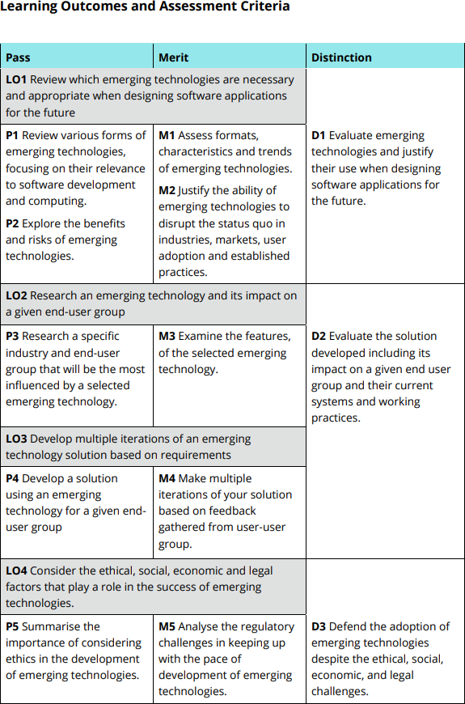

**Pearson Higher Nationals in**

Computing

47: Emerging Technologies

Assignment 01 of 01

# Acknowledgement

I received many opinions and advice from various people to successfully complete the assessment assigned to us for the subject of **Unit 47: Emerging Technologies, Expo Technologies - ET & the Future** in our HND course. I express my gratitude to all of them. First, I would like to thank my mother and father for being there for me and supporting me and encouraging me. Also, I would like to express my gratitude to my lecturer, Ms. Sinduja Chamari Thilakarathne, who guided me to complete this work successfully. I would also like to express my gratitude to my other lecturers, who helped me to complete my assessment successfully. And last, I would like to thank who help me with my feedback forms, and who gave their opinions on new technologies that we discussed in my assignment below.

Last without their support and cooperation I would not have completed this assignment in the given time.

# Table of Content

Table of Contents

Acknowledgement 13

Table of Content 14

Table of Figures 14

Activity 01 16

What is Emerging Technology 16

Characteristics of Emerging Technology 16

Various Forms of ET & Trends 18

Artificial Intelligence (AI) 18

IoT Security Enhancements 21

How do these technologies relate to the Software Industry? 27

Nanotechnology: 27

Holography: 27

Advantages of ET 28

Artificial Intelligence (AI) 28

Internet of Things (IoT) 30

Blockchain 30

Big Data 31

Immersive Media (VR/AR/MR/360) 32

Cloud Computing 33

What Are Emerging Technology Risks? 33

Artificial Intelligence (AI) 34

Internet of Things (IoT) 34

Blockchain 35

Big Data 35

Immersive Media (VR/AR/MR/360) 36

Cloud Computing 36

Alterations due to New Technologies in the Business Sector 37

The Scope of the Market and Responses 38

Activity 02 40

Industry Most Influenced by AI Technology 40

How the Healthcare Industry Influenced by AI Technology 41

How Patients Aged 20-45 are Influenced by AI in Healthcare Industry? 42

Features of AI in Healthcare 43

Multiple Features and Capacities of AI in Healthcare 44

AI Growth Opportunities in Healthcare 45

Create a PowerPoint presentation about our AI solution. 46

Activity 03 53

AI to improve treatment efficacy and speed up diagnosis 53

Providing a solution to people who are busy and haven’t time to take care of their health at the age of 20 to 45 years old. 53

What do we expect from the Healthcare System and the AI Chatbot? 54

The advantage of using an AI based chatbot. 55

Design an AI Chatbot to fulfill the requirements. 56

Impact of AI on Healthcare for Patients Aged 20-45 63

Activity 04 65

Ethical Impact from Emerging Technologies 65

Environmental Pollution 65

Social Behaviors 65

Mental Health Ethics 66

Physical Health 66

Legal Implications and Human Rights 67

Cultural Impact 68

Religious Beliefs 68

Challenges and Problems When Introducing New Emerging Technologies. 69

How to Keep Up with Emerging Technologies 70

Get Patents 70

Show Off on TV Invention Programs 70

Use Social Media to Spread the Word 70

Technology Adoption Process. 70

Technology Adoption Process 72

Conclusion 73

Reference list 74

# Table of Figures

Figure 1 Emerging Technologies 19

Figure 2 edge computing 23

Figure 3 Quantum Computing 25

Figure 4 A simplified illustration of blockchain 26

Figure 5 Automation 27

Figure 6 AI technology in healthcare industry. 43

Figure 7 Advantages of using AI chatbots in Heathcare 59

Figure 8 Medical System Login 60

Figure 9 Medical System Register window 61

Figure 10 Medical System Chatbot 62

Figure 11 Medical System Appointment window 63

Figure 12 Medical System wallet 64

Figure 13 Medical System Records 65

Figure 14 Consumer feedback form page 1 66

Figure 15 Consumer feedback form page 2 67

Figure 16 Consumer feedback form page 3 68

Figure 17 Consumer feedback form page 4 69

Figure 18 Login page 1 69

Figure 19 feedback for colors 70

Figure 20 Chatbot feedbacks 70

Figure 21 image feedback 71

Figure 22 Feedback form results 1 71

Figure 23 login page 02 72

Figure 24 feedback for colors 72

Figure 25 feedback for Chatbot 73

Figure 26 feedback for images 73

Figure 27 feedback form after the changes. 74

Figure 28 before the changes 75

Figure 29 after the changes 75

Figure 30 5 stages of customer adoption 90

Figure 31 Technology adoption curve 91

# Activity 01

## What is Emerging Technology

When used in different fields, such as in the area of media, business, science, or education, the definition of "emerging technology" can have slightly varied meanings. It is typically used to describe a new technology, but it can also refer to the ongoing evolution of an existing technology. The phrase is normally reserved for technologies that are having, or are anticipated to have, a major social or economic impact. It often refers to technologies that are in development or that should be accessible within the next five to 10 years (Winston & Strawn, 2023).

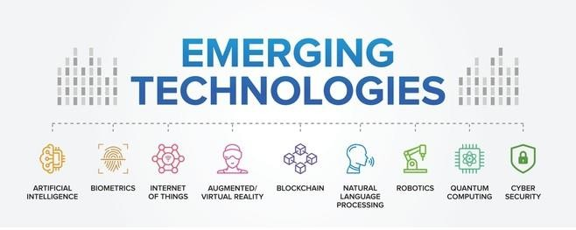

*Figure 1 Emerging Technologies*

### Characteristics of Emerging Technology

Emerging technologies (ETs) are different than existing technologies in a number of ways, including the following:

* High Uncertainty:
  + It's common for the future evolution and consequences of ETs to be uncertain. It is difficult to predict results and make long-term plans because of this

unpredictability, which extends to technological viability, commercial acceptability, and regulatory approval.

* Network Effects:
  + When more people use ETs, they usually become more valuable, which accelerates their adoption and influence through a positive feedback loop. Network effects are a key factor driving the expansion of ET, with advantages increasing with wider adoption.
* Unexpected Social and Ethical Implications:
  + The use of ETs may give rise to unanticipated social and ethical conundrums. As technology becomes more pervasive in daily life, problems including employment displacement, privacy issues, and shifting social dynamics frequently surface.
* Cost:
  + The early stages of ET development and implementation may be expensive. Due to the high expenses of early-stage production and research & development, access is sometimes restricted to a small number of organizations or individuals.
* Unobvious influence:
  + It could take some time to fully realize how much of an influence ETs have. Sometimes their effect doesn't become apparent until long after they are widely adopted, spreading in unforeseen ways across many industries and facets of society.
* Limited to Creator:
  + During the initial phases, ETs are frequently only available to their inventors and a select few early users. High expenses, intricate technology, or proprietary limitations may be the cause of this restriction.
* Not Totally Investigated and Researched:
  + Extraterrestrials (ETs) are frequently at the cutting edge of scientific and technical understanding, which means they haven't been fully explored or understood. A lack of thorough study may result in gaps in our knowledge of their hazards and full potential.

## Various Forms of ET & Trends

Many industries, including the software business, are undergoing a change because to emerging technologies, or ETs. The descriptions of a few important ETs and how they relate to software development and innovation are provided here.

* AI
* IOT
* Mobile & Social Internet
* Block Chain
* Big Data
* Automation
* Robotics
* Immersive Media (VR/AR/MR/360)
* Cloud Computing
* Voice Assistant
* Nanotechnology
* Holography

### Artificial Intelligence (AI)

AI is the development of systems that are capable of learning, solving problems, and decision- making that traditionally require human intellect. Subfields include deep learning, which use neural networks to understand complicated data patterns, and machine learning, where algorithms become better with practice.

*Examples: apply to deep learning and machine learning.*

#### Internet of Things (IoT)

In the digital world, the Internet of Things (IoT) is a revolutionary breakthrough. It entails attaching commonplace items to one another and allowing them to exchange data, which produces better workflows and new services.

IoT is significant because:

* Boosts productivity
* Supports data-driven decision-making
* Promotes financial savings

These advantages are seen in a number of sectors, including manufacturing and healthcare. Recent findings indicate that the usage of IoT will likely increase due to advances in cybersecurity, 5G, and AI. It is anticipated that these technologies will create even more avenues for innovation in sectors such as industries, smart cities, and healthcare.

#### Edge computing

Edge computing in the context of IoT means processing data at the edge of the network, near where it is generated by IoT devices. This approach is important for handling the large amounts of data produced by IoT devices efficiently and effectively.

By processing data locally, edge computing:

* + - * + Reduces latency
        + Enhances operational efficiency
        + Allows for real-time analytics, which is particularly beneficial in time-sensitive applications.
        + Integrating edge computing with IoT can result in:
        + Improved network bandwidth
        + Reduced communication latency
        + The ability to maintain operations even when offline.

These benefits make edge computing an essential part of the growing world of IoT solutions.

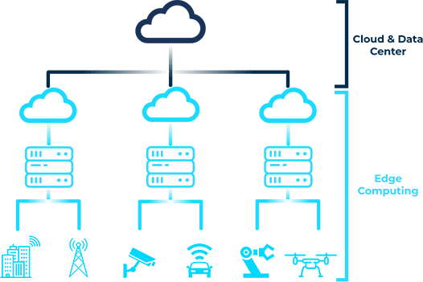

*Figure 2 edge computing*

#### 5G Connectivity

5G technology is the latest mobile network technology, bringing with it a range of benefits:

* + - * + Higher multi-Gbps peak data speeds
        + Ultra-low latency
        + Increased reliability
        + Massive network capacity
        + A more consistent user experience

These improvements are particularly important for the Internet of Things (IoT). 5G's ability to support a significantly larger number of connected devices while consuming less power

greatly enhances what the IoT can do. This combination of 5G and IoT opens up possibilities for various new applications, such as:

* Remote monitoring
* Autonomous operations
* Smart cities

All of these rely on devices being able to communicate with each other seamlessly and in real-time, which is made possible by the infrastructure provided by 5G.

## IoT Security Enhancements

Security is extremely important in the Internet of Things (IoT) because it ensures that interconnected devices, which are everywhere nowadays, are secure and private. However, there are several challenges in this area:

* + - * + Weak password protection
        + Insufficient data encryption
        + Difficulty in patching and updating devices

To overcome these vulnerabilities, experts are looking into new solutions:

1. Federated learning combined with blockchain for decentralized security
2. Artificial intelligence and machine learning to anticipate and prevent potential risks

These advancements aim to strengthen the IoT system against an increasing number of cyber threats

###### Quantum computing

Quantum computing is like a major upgrade for computer power. It taps into the funky world of quantum mechanics to process information in super cool ways that regular computers just can't handle. See, it uses these things called qubits, which can be in multiple states all at once. That means quantum computers can do complex calculations crazy fast, way faster than your

usual computer. This technology is a big deal because it has the potential to push forward all sorts of fields. It could help solve some seriously tough problems in science and industry that we're grappling with today.

*Figure 3 Quantum Computing*

###### Blockchain

Blockchain technology has totally changed the way we think about keeping our data secure and ensuring the integrity of transactions. It's pretty cool because it's decentralized, which means no one entity has complete control over the whole network. That makes it super tough for any funny business or corruption to happen. And get this, blockchain isn't just for cryptocurrencies. People are also looking into using it for things like managing supply chains, voting systems, and even protecting intellectual property rights. It's seriously amazing how it can build trust and improve efficiency in so many different industries.

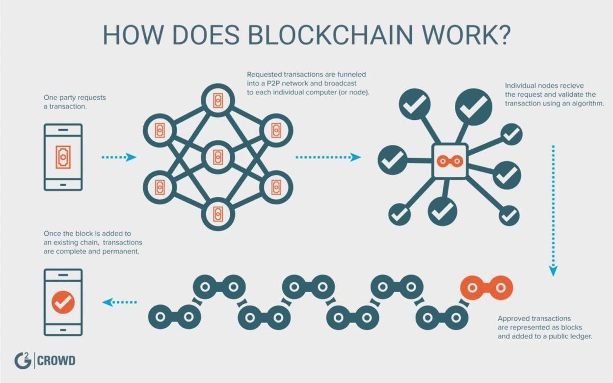

*Figure 4 A simplified illustration of blockchain*

###### Big Data

Big Data is totally transforming the software industry. It's like this game-changer that's taking things to a whole new level. With the power to process and analyze gigantic datasets, businesses can now uncover all these hidden patterns, market trends, and even customer preferences. It means they can make smarter decisions by analyzing the datasets and data patterns.

Software companies are really stepping up their game to handle the complexity of Big Data. They're developing these seriously sophisticated tools that can handle all that data like a boss. And it’s giving organizations a huge competitive edge in their markets. It's like Big Data is the secret weapon that's propelling innovation and efficiency across all sorts of industries. So, the impact of Big Data on the software industry is no joke. It's changing the game and making things better for everyone involved.

###### Cloud Computing

Cloud computing has completely transformed the software industry by offering a super flexible, scalable, and cost-effective way to deliver technology services. It's like a game- changer for developers, allowing them to create and launch applications faster than ever. They can easily adjust the resources to meet the demand.

Cloud services also make it a breeze for teams spread out across different locations to collaborate. This boosts innovation and speeds up the whole development process. It's not just about making things run smoother, though. The beauty of cloud computing is that it gives businesses of all sizes a fair shot at accessing advanced computing capabilities. It levels the playing field in the digital marketplace.

###### Automation

Automation is changing the dynamism of the software industry by putting it on a new track of efficiency, accuracy, and cost-effectiveness in its developmental procedures. Forefront position about Robotic Process Automation and AI-driven intelligent automation systems is giving a new dimension. Automation of not only the mundane task but also brought advanced capabilities, such as Predictive Analytics and Smart Decision Making. Hence, it helps businesses to speed up Digital Transformation. It shall Innovate and Help in Keeping Pace with Fast-Changing Technological Environment.

*Figure 5 Automation*

###### Voice Assistants

These voice assistants will be powered with artificial intelligence to understand spoken commands and react accordingly. Examples include Amazon's Alexa, Apple's Siri, and, even more importantly, the company's Google Assistant itself.

It is going to be necessary to develop voice-enabled applications and integrate voice interfaces into software products. On the other hand, voice assistants provide greater accessibility and higher user engagement for their users by providing hands-free interaction with digital services.

###### Nanotechnology

Nanotechnology is related to handling material in the atomic and molecular region, usually between 1 and 100 nanometers. At this scale, materials can exhibit unique properties different from their larger ones. Nanotechnology finds place in many fields of research, such as medicine, electronics, and materials science.

* + - 1. Applications and Trends:
* **Medicine:** The new technology makes changes in the drug delivery systems to targeted therapy with reduced side effects and more efficient medicines. Nanoparticles deliver the drugs directly to the cancer cells themselves or repair damaged tissues entirely at a cellular level.
* **Electronics:** Electronic components are being created at a nanoscale to be smaller, faster, and increasingly efficient in their working. Quantum dots and carbon nanotubes find their applications in transistor and memory storage devices.
* **Materials Science:** The development of nanomaterials like graphene leads to more potent, lightweight, and conductive materials. These are further used in building stronger binding materials for construction, developing new batteries, and developing more electronically advanced textiles.
* **Energy:** Nanotechnology improves efficiency in renewable sources of energy. For example, nanomaterials are used in solar panels to increase their energy absorption and conversion efficiency.

###### Holography

One way to explain holography is that it involves a technique of capturing the pattern of light reflected from an object to create a three-dimensional image of such an object. Holograms seen without special glasses seem to move and change, depending on the viewing angle. Holography makes use of the interference of light beams from a laser or coherent light source.

* + - 1. Applications and Trends:
* Entertainment and Media:
  + These holographs are in wide usage in today's concerts, museums, and exhibitions to allow for much more life-like 3D displays of performers, historical figures, or works of art. This technology advances the viewer experience by making it ever more interactive and immersive. Imaging for Medicine: Holography is engaged in further advanced techniques of medical imaging. Detailed holograms of internal organs and tissues will help in diagnosis and surgical planning.
* Data Storage:
  + H pure holographic data storage is much denser, with quicker retrieval rates than traditional forms of storage. This technology uses 3D holograms to store data throughout the volume of a medium and not only on the surface.
* Augmented Reality:
  + Holography is going to play an important role in the growth of AR. It will provide real 3D image overlays of the real world realistically for applications such as gaming to distributed collaboration and training.

## How do these technologies relate to the Software Industry?

Artificial Intelligence (AI) and the Internet of Things (IoT) are two crucial technologies shaping the software industry:

* **AI:** Creating systems that can perform tasks typically requiring human intelligence, such as learning, decision-making, and problem-solving.
* **IoT:** Connecting everyday devices to the internet, allowing them to send and receive data, enhancing automation and efficiency.

Other significant technologies in the software industry include:

* **Blockchain:** A secure way to record transactions, revolutionizing areas like supply chain management and finance.
* **Big Data analytics:** The ability to handle vast amounts of data, providing insights that drive decision-making in software development.
* **Cloud Computing:** On-demand availability of computer system resources, particularly data storage and computing power, without direct active management by the user. This is essential for scalable software solutions.
* **Robotics:** The design and use of robots, increasingly integrated with software systems for automation and enhanced productivity in various industries.

### Nanotechnology:

* Simulation and Modeling Software: Sophisticated software for simulation and modeling would be required to develop nanomaterials and nanodevices. This will enable researchers to understand, get a grip on, and predict the behavior of materials at the nanoscale level.
* Healthcare Applications: Software managing, analyzing these large produced datasets from research in the field of nanotechnology, including bioinformatics tools and designing platforms brought forward for targeted drug delivery systems.

### Holography:

* Holographic Display and Interfaces: One cannot underestimate the software development that goes into creating and managing holographic displays, particularly in rendering 3D holographic images, integration into user interfaces, and interaction with other elements of the digital space seamlessly.
* Content Creation and Management: Special software is needed to develop, edit, and play back holographic content. Ends of this pipeline include specialized tools for 3D modeling, animation, and real-time rendering.
* AR Applications: Software development for holography-based augmented reality applications will be complex, this being the integration of real-world data with holographic overlays; such development demands sophisticated algorithms in the areas of tracking, rendering, and user interaction.

## Advantages of ET

The uncertainties associated with implementing novel and disruptive technologies are known as emerging technology risks. For instance, cloud computing brings risks like vendor lock- in, talent gaps, and potential service failures along with its benefits of flexibility and scalability. When it comes to developing technological risks, proactive methods like scenario analysis and environmental scanning are necessary, in contrast to conventional business risks, which are often reduced by well-established contingency plans. They also demand a greater threshold for uncertainty, which can make management more difficult because of ambiguous ownership (ISACA, n.d.).

### Artificial Intelligence (AI)

Artificial Intelligence (AI) is fundamentally reshaping numerous industries by taking over routine tasks, enhancing decision-making processes with data-driven insights, and providing highly personalized user experiences. With the power of predictive analytics, AI can anticipate trends and behaviors, enabling businesses and healthcare providers to adopt proactive strategies. In medicine, AI significantly boosts patient care through innovations like voice-activated assistants and smart chatbots, which streamline various processes.

Additionally, AI is essential in identifying fraudulent activities by detecting patterns indicative of suspicious behavior. These innovations merely scratch the surface of AI's transformative potential, hinting at a future where its capabilities continue to expand and evolve.

1. Enhanced Decision-Making: With AI systems, we can analyze huge amounts of data in a flash, getting valuable insights and helping us make smarter decisions based on real facts.
2. Personalization: Thanks to AI, we can create personalized experiences in all sorts of applications, like customer service and marketing, making everything feel tailor-made just for you.
3. Predictive Analytics: AI algorithms have this cool ability to predict trends and outcomes, which is super helpful for businesses to plan ahead and strategize effectively.
4. Improved Healthcare: AI is a game-changer in the world of healthcare, helping with things like diagnostics, personalized medicine, and even coming up with new treatments.
5. Natural Language Processing: AI makes talking to machines a breeze, whether it's through voice commands or chatbots. It's all about enhancing the way we interact and making the user experience even better.
6. Fraud Detection: AI systems are like superheroes when it comes to spotting suspicious patterns and catching potential fraud in financial transactions. They keep us safe and secure.

### Internet of Things (IoT)

1. **Efficiency and Automation:** With the Internet of Things (IoT), we can automate processes and keep a real-time eye on things, making various applications more efficient.
2. **Data Collection:** IoT devices are like data magnets, collecting huge amounts of valuable information that can help us make better decisions.
3. **Improved Resource Management:** Thanks to IoT, we can optimize the use of resources in all sorts of ways. From managing energy in smart grids to monitoring water usage in agriculture, we're getting smarter about how we use what we've got.
4. **Enhanced Customer Experience:** IoT is all about personalization. It can make your smart home or connected devices tailor-made to your preferences, giving you a top- notch user experience.
5. **Predictive Maintenance:** IoT sensors are like fortune-tellers for machinery. They can predict when something might go wrong and schedule maintenance before it becomes a major headache, so you can keep things running smoothly.
6. **Health Monitoring:** Wearable IoT devices are like your own personal health coaches. They can keep an eye on your vital signs and give you real-time feedback about how you're doing, which is pretty nifty for both you and your healthcare provider.
7. **Safety and Security:** IoT has got your back when it comes to safety and security. By connecting surveillance systems and emergency response mechanisms, we can keep a closer eye on things and respond quickly when needed. Peace of mind at its finest.

### Blockchain

1. **Decentralization:** The beauty of blockchain is that it operates without a central authority, which means there's no single point of failure to worry about.
2. **Transparency:** One of the greatest advantages of blockchain is that it brings transparency to transactions. Anyone can audit and verify transactions, which helps build trust in the system.
3. **Security:** Blockchain's cryptographic technology makes it incredibly secure against tampering and fraud. You can rest assured that your data is well protected.
4. **Immutability:** Once data is recorded on a blockchain, it becomes etched in stone. It can't be altered or tampered with, ensuring the integrity and reliability of the information.
5. **Efficiency:** Blockchain has the power to simplify processes and cut out the need for intermediaries. This not only streamlines things but also lowers transaction costs.
6. **Smart Contracts**: Imagine contracts that can execute actions automatically when certain conditions are met. That's the magic of smart contracts, which enhance efficiency and reduce manual intervention.
7. **Financial Inclusion:** Blockchain has the potential to bring financial services to the unbanked population through decentralized finance (DeFi). It's a game-changer that can empower people who previously had limited access to financial services.

### Big Data

1. **Enhanced Decision-Making:** When it comes to making important choices, big data analytics is a game-changer. It provides valuable insights that help us make informed decisions.
2. **Improved Customer Insights:** Businesses can now dive deeper into understanding their customers' behaviors and preferences. It's like having a secret decoder that unlocks valuable insights about what makes our customers tick.
3. **Operational Efficiency:** By analyzing massive amounts of data, we can uncover hidden inefficiencies and optimize our operations. It's like shining a spotlight on areas that need improvement, leading to smoother and more efficient processes.
4. **Predictive Analytics:** Big data is like a crystal ball that allows us to predict trends and behaviors. Armed with this knowledge, we can take proactive measures to stay ahead of the game and make smart strategic moves.
5. **Innovation:** With access to vast amounts of data, we have the power to drive innovation in our products and services. It's like having a treasure trove of ideas that can fuel our creativity and push us to think outside the box.
6. **Competitive Advantage:** Organizations that harness the power of big data gain a significant edge over their competitors. It's like having a secret weapon that helps us stay one step ahead and outperform the competition.
7. **Personalization:** Big data enables us to create personalized experiences for our users and customers. It's like tailoring our offerings to suit their individual needs and preferences, making them feel valued and special.

### Immersive Media (VR/AR/MR/360)

1. Enhancing User Experience: Immersive media brings you captivating and interactive experiences that truly draw you in.
2. Training and Education: Virtual Reality (VR) and Augmented Reality (AR) have the power to create lifelike training environments, taking learning outcomes to a whole new level.
3. Design and Visualization: These incredible technologies allow for incredibly detailed visualization in fields like architecture and design, giving professionals a whole new perspective.
4. Entertainment: Immerse yourself in a whole new realm of entertainment with immersive media, whether it's gaming that makes you feel like you're in the action or virtual concerts that transport you to the front row.
5. Remote Collaboration: With VR and AR, collaborating remotely feels more personal than ever, as if you're right there with your teammates, even if you're miles apart.
6. Healthcare: VR and AR are revolutionizing healthcare by being used for therapeutic purposes and providing surgeons with realistic surgical simulations to enhance their skills.
7. Marketing and Retail: Immersive media takes marketing campaigns to the next level, grabbing attention and creating unforgettable experiences. It also allows for virtual try-on experiences in the retail world, making shopping more convenient and exciting.

### Cloud Computing

1. **Scalability**: You can adjust how much cloud service you use based on what you need.
2. **Cost-Effectiveness**: You don't need as many physical machines or buildings, which cuts down on cost when you use cloud computing.
3. **Accessibility**: You can use cloud services from anywhere as long as you have an internet connection.
4. **Collaboration**: Cloud computing lets multiple people work on a project at the same time.
5. **Disaster Recovery**: Many cloud services have strong backup and recovery options in case something goes wrong.
6. **Automatic Updates**: The people who provide the cloud service take care of updating and maintaining the software, so users don't have to worry about it.
7. **Environmental Impact**: Cloud computing uses less energy compared to traditional data centers making it better for the environment.

## What Are Emerging Technology Risks?

Emerging technologies have the power to completely change sectors by bringing previously unseen levels of creativity and efficiency. However, as they develop, the significance of strong security standards, ethical guidelines, and compliance cannot be emphasized. The course of sustainable and responsible technology progress will be determined by this balance between implementation advantages and hazards that will be minimized.

Automation of Tasks: AI can take care of those repetitive and boring tasks, making things more efficient and giving humans the chance to focus on more interesting and complex stuff.

### Artificial Intelligence (AI)

1. **Job Displacement:** Automation can lead to job losses, especially in repetitive businesses.
2. Bias and lack of bias: AI systems can perpetuate or exacerbate biases in training data, leading to inappropriate results.
3. **Privacy concerns:** The ability of AI to analyse large amounts of personal data raises significant privacy concerns.
4. **Security risks:** AI systems can be vulnerable to attack and manipulation, with potentially serious consequences.
5. **Dependence:** Over-reliance on AI can reduce human skills and critical thinking.
6. **Ethical issues:** The development and use of AI raises ethical questions, especially with regard to autonomous decision-making.
7. **Lack of transparency:** AI algorithms can be complex and opaque, making it difficult to understand how decisions are made.

### Internet of Things (IoT)

1. **Security Vulnerabilities:** IoT devices are often targets for cyber-attacks, which can compromise personal and organizational data.
2. **Privacy Concerns:** The thing with IoT devices is that they're often collecting a ton of data, and that can raise some serious privacy concerns.
3. **Interoperability:** One of the challenges with IoT is that different devices and systems don't always play nicely together, causing integration headaches.
4. **Complexity:** It's no joke trying to manage and keep up with a whole network of IoT devices. It can be a real headache and drain your resources.
5. **Dependence on Connectivity:** Since IoT devices rely on always being connected to the internet, any network failures can leave them vulnerable and useless.
6. **Data Overload:** The amount of data these IoT devices churn out can be overwhelming. It's like drinking from a firehose and trying to make sense of it all.
7. **Regulatory Issues:** The growth of IoT tech is moving so fast that regulations often can't keep up. That means businesses are left dealing with compliance headaches.

### Blockchain

1. **Scalability Problems:** Blockchain networks can face issues with scalability, which can result in slower transaction times and higher fees.
2. **Energy Consumption:** Blockchain, especially proof-of-work systems, can consume a significant amount of energy.
3. **Regulatory Uncertainty:** The legal and regulatory status of blockchain technology varies widely, creating a lot of uncertainty.
4. **Security Risks:** While blockchain itself is secure, applications and smart contracts associated with it can be vulnerable to attacks.
5. **Irreversibility:** Mistakes or fraudulent transactions on a blockchain cannot be easily corrected due to its unchangeable nature.
6. **Privacy Concerns:** Although blockchain transactions are transparent, they have the potential to expose sensitive information.
7. **Complexity:** Developing and managing blockchain solutions can be technically complex and require a lot of resources.

### Big Data

1. **Privacy Concerns:** When it comes to collecting and analyzing large volumes of personal data, there are some serious privacy issues to consider.
2. **Data Security:** Keeping big data secure is no easy task, as there's always a risk of breaches and cyber-attacks.
3. **Data Quality:** It's important to note that poor-quality data can lead to misleading insights and flawed decision-making.
4. **Cost:** Managing and processing large datasets can be quite pricey and resource- intensive.
5. **Complexity:** Analyzing big data requires advanced tools and expertise, which adds to the complexity of the task.
6. **Regulatory Compliance:** Making sure that data protection regulations are upheld can be quite challenging.
7. **Ethical Considerations:** The use of big data raises ethical concerns, especially when it comes to data usage and consent.

### Immersive Media (VR/AR/MR/360)

1. **Pricey development**: It can cost a lot to make and use immersive media technologies.
2. **Health worries**: Too much VR can cause sickness and sore eyes.
3. **Privacy**: Using immersive media can collect a lot of personal data which can worry some people.
4. **Security**: This technology can get hacked and have data stolen.
5. **Digital Gap**: If you're poor, you might not be able to use immersive media. This is called a digital divide.
6. **Content Quality**: Making good immersive content can be hard and need a lot of resources.
7. **Addiction**: Immersive media can be so fun that people might use it too much and get addicted.

### Cloud Computing

1. **Risks to Security**: Data in the cloud may fall prey to online dangers and data leaks.
2. **Service Interruptions**: Cloud systems can sometimes go down and this disrupts easy access and work efficiency.
3. **Privacy of Data**: Keeping information private in the cloud is tough, given the different rules in place.
4. **Bound by Supplier**: Getting too dependent on one cloud provider could make it hard to shift to another one.
5. **Regulation Adherence**: Meeting industry rules could get complicated when we're dealing with the cloud.
6. **Spending Management**: While it's good for the budget, controlling and fine-tuning cloud costs could be tough.
7. **Restrained Control**: Compared to traditional means, users have fewer options to meddle with the infrastructure and data protection methods when dealing with cloud service.

## Alterations due to New Technologies in the Business Sector

Artificial Intelligence (AI)

* **Changes in Industry**: Things are changing because of AI - it's automating tasks bettering the analysis of data, and spicing up customer service with chatbots.
* **How Users are Adjusting**: AI is becoming a normal part of life. Folks like the customization but are stressed about privacy and losing their jobs.
* **Example to Consider**: AI has given us helpful buddies like Siri and Alexa, which are now everyday items.

Internet of Things (IoT)

* **Changes in Industry**: Smarter homes and automated industries are a sign of IoT making things more efficient and collecting data better.
* **How Users are Adjusting**: More and more people are using smart devices as they become cheaper. They love the ease but are tensed about keeping their info safe.
* **Example**: User behavior helps gadgets like Nest thermostats to learn.

Blockchain

* **Changes in the industry**: Increase in the transparency and security of dealings in finance and management of supply chain.
* **Adoption by Users**: The adoption is steady due to the sophistication and worries about regulations; viewed as life-altering but also susceptible to speculation.
* **Illustration**: The attention of the mainstream is garnering towards Cryptocurrencies such as Bitcoin.

Big Data

* **Transformation in industries**: Decisions based on data, plus enhanced understanding of customers.
* **Adopted by users**: Recognition in business and healthcare is widespread; users often don't realize its application but enjoy personalized services.
* **Example**: Stores are making use of data analysis to better their inventory and marketing.

Immersive Media (VR/AR/MR/360)

* **Changes in Industry**: Gaming, schooling, and training are having new experiences.
* **Adoption by Users**: People in entertainment are liking it a lot; but others are not so quick due to costs and not enough content.
* **Example**: Pokémon Go made AR famous in gaming.

Cloud Computing

* **Changes in Industry**: Movement from in-house systems to flexible, on- demand resources.
* **Adoption by Users**: Lots of people are into it because it saves money and it's easy to use; but they're still worried about keeping their data safe.
* **Example:** Companies are shifting to platforms such as AWS and Azure.

## The Scope of the Market and Responses

* Thoughts and Responses of People:
  + New technologies bring along ease and improvements, which excite people. But, worries are also there about privacy, security, and how it will affect jobs.
  + **Example**: Use of AI in hiring has made the process smoother. Still, the people applying for jobs feel anxious about unfairness in the systems used.
* The Approach to Touch New Market with ET:
  + **Spreading Knowledge and Making Aware**: Telling those who might use about the benefits and safe ways can make them use it more.
  + **Example**: Companies that provide services for computing through the cloud give free testing periods and materials. This is done to help firms adapt.
  + **Teaming up and Working Together**: By working together with companies that are already trusted, trust can be built and more people can be reached.

IoT businesses are teaming up with makers of home appliances to include smart tech.

# Activity 02

## Industry Most Influenced by AI Technology

Artificial Intelligence has not come to shape how we interact with technology but also to revolutionize the workings of businesses and whole industries. This technology holds high regard among firms and workers in Spain. A HubSpot study shows that 88% believe AI is essential in their day-to-day tasks.

Artificial intelligence promises to boost our life quality by enhancing services across various sectors. In this context, knowmad mood, a technology consultancy specializing in digital transformation services, identifies five sectors where AI has made a lasting impact and continues to bring about significant changes (KnowMadMood, 2023).

* **Healthcare:** AI to improve treatment efficacy and speed up diagnosis
* **Insurance and Finance:** AI for risk detection and financial prediction
* **Industrial and energy sector:** AI for sustainable, efficient and flexible production
* **Education and training:** AI as the key to the learning experience
* **Security and surveillance:** using AI to anticipate crime
* **Human Resources:** optimizing recruitment and talent management processes

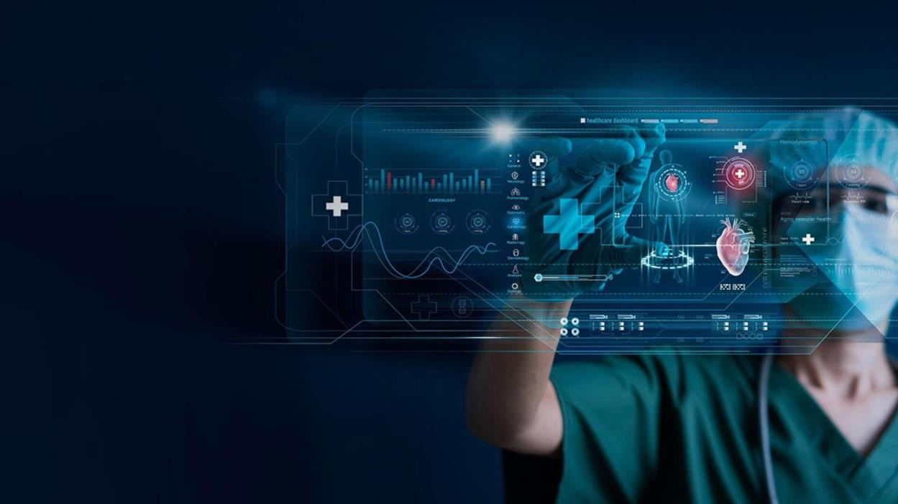

*Figure 6 AI technology in healthcare industry.*

## How the Healthcare Industry Influenced by AI Technology

AI is changing healthcare by making patient care better and more efficient. AI helps doctors diagnose diseases faster and more , which lets them treat patients sooner. For example, AI can look at medical images very and help find diseases like cancer on. Personalized medicine is getting better too. AI systems such as IBM's Watson for Oncology look at patient data and help create treatment plans just for them, which helps patients get better results. Also, AI can predict healthcare needs very well. It can guess when disease outbreaks will happen or when many patients will come to hospitals. This helps hospitals use their resources in the best way. AI also helps with office work. AI chatbots handle scheduling and questions, which lowers costs and lets healthcare workers spend more time with patients. These points show how AI is making a big difference in healthcare and leading to a future where technology and medicine work together to give patients the best care possible.

Here is how AI is changing healthcare by improving diagnosis, personalizing treatment methods and advancing health management.

* Enhanced Diagnostics: AI algorithms with high precision rate analyze medical images such as X-ray and MRI thus helping doctors to diagnose illnesses including cancer early and accurately.
  + Example: Google's DeepMind AI has been used to identify over 50 eye diseases just like human experts.
* Personalized Treatment Plans: By analyzing patients’ data, AI can provide personalized treatment plans thereby improving the results of the treatment through individualizing the patient needs.
  + Example: IBM’s Watson for Oncology offers evidence-based treatment options to oncologists
* Predictive Analytics: AI analyzes huge datasets to predict disease outbreaks, patient admissions and other potential health problems leading to proactive healthcare.
  + Example: Predictive models for flu outbreak detection and resource allocation.
* Operational Efficiency: This involves AI taking up administrative tasks such as scheduling appointments, making billings or managing patient records thus reducing costs and improving efficiency in service provision in a hospital.
  + Example: Routine inquiries and appointment booking are taken care of by AI chat bots releasing healthcare personnel for other duties.

## How Patients Aged 20-45 are Influenced by AI in Healthcare Industry?

The health industry is being transformed by Artificial Intelligence (AI), especially in the case of patients aged 20-45. This group, usually tech-savvy and constantly on the move, enjoys much benefit from AI innovations. Young people can take advantage of telemedicine platforms, which are driven by AI, to have consultations remotely without leaving their places for more convenient medical services based on geography. On top of this, wearable technology powered by artificial intelligence ensures that a person’s health is tracked at all times resulting in data that can lead to proactive health management. Such devices as Fitbit and Apple Watch not only measure one’s fitness levels but also look for patterns in the provided information.

Furthermore, AI aids diagnosis for faster and accurate identification of health conditions thus facilitating timely treatment of such ailments. Similarly, applications like SkinVision depend on AI algorithms that analyze skin photos as a means detecting signs of potential problems earlier; this age bracket is at higher risk for skin diseases compared to others. Furthermore, using AI to mine huge amounts personal medical data helps provide tailored healthcare advice thus encouraging healthier living styles among different individuals. Nutrition apps integrate machine learning into creating personalized meal plans suitable to each person’s particular requirements and desires. Overall, AI in healthcare helps young adults a lot. It gives tools for easier access better monitoring smarter diagnosis, and care made just for you so health results get better. AI is more than new technology; it changes the way healthcare reaches and feels to the younger crowd.

Healthcare that Is More Accessible:

* AI-aided telemedicine systems facilitate remote consultations and this can make healthcare accessible even to young and busy people. For instance, Babylon Health offers virtual consultations and health monitoring.

Health Monitoring and Management:

* Devices like wearables with an inbuilt artificial intelligence are used to monitor health metrics such as heart rate or activity level. Therefore, one can take care of his own health properly. Fitbit and Apple Watch use artificial intelligence in designing fitness routines for different users.

Faster and Accurate Diagnoses:

* The youth have been able to get timely treatment because AI helps in quickly diagnosing sicknesses accurately. SkinVision is a typical AI-based app for dermatology that enables its users to identify skin problems early enough.

Personalized Health Recommendations:

* Artificial Intelligence powered apps provide personalized advice on health and wellness based on individual data promoting healthier lifestyles. MyFitnessPal is an example of an AI nutrition app which offers personal exercise plans and diet.

## Features of AI in Healthcare

AI in healthcare is set for big changes aiming to change how we care for patients and manage their health. By 2030, AI will use lots of different data sources to find patterns in diseases help with treatment and care, and let healthcare systems know the risks of diseases for each person and recommend how to prevent them. Tools like AI-assisted radiology will make diagnosing faster, as shown by kidney volume analysis now taking seconds instead of 45 minutes. Also, AI will be very important in figuring out how social factors affect health leading to more proactive and tailor-made health plans. Using AI could make paperwork easier, improve how patients are involved, and lead to better health results through more right

diagnoses and better treatment options. As AI gets better, it will handle many tasks, from looking over medical records to talking with patients making a big difference in how healthcare is provided. AI working together with healthcare workers will focus on making things more efficient cutting down wait times, and in the end giving better care to patients.

### Multiple Features and Capacities of AI in Healthcare

* Diagnostic Imaging:
  + Mastering such skills as medical imaging interpretation helps find anomalies quickly.
* Predictive Analytics:
  + Artificial intelligence predicts the outcomes of patients, but also tracks emergence of diseases or tendencies in healthcare.
* Personalized Medicine:
  + Customized medications are generated by artificial intelligence basing on individualized patient data.
* Virtual Health Assistants:
  + Subsequently they will do this through chatbot integration which gives health related information and books appointments for them.
* Remote Monitoring:
  + Wearables driven by artificial intelligence (AI) keep track of major health metrics and notify users about potential problems beforehand.
* Clinical Decision Support:
  + It is using medical knowledge to offer evidence-based advice to healthcare professionals meant for use at the point of care during decision making moments.
* Drug Discovery:
  + One way through which Artificial Intelligence has been employed to analyze different data types that expedite discovery process of new drugs.

### AI Growth Opportunities in Healthcare

The combination of AI and IoT to monitor health is causing a revolution in patient care by enabling real-time tracking of vital signs and personalized health alerts. Predictive disease models are growing in sophistication, which allows for earlier and better diagnoses. Telemedicine driven by AI, is broadening healthcare access in remote places by making medical consultations more convenient and effective. Treatments personalized to individual genetic profiles are improving patient outcomes. , AI's role in mental health support is increasing providing new methods to diagnose and treat mental health issues and making care more accessible and effective. As technology progresses, the potential of AI in healthcare keeps growing, with big promises for better patient care and health management.

1. **Combining with IoT**: AI and IoT devices together will enhance health monitoring and management.
2. **Better Predictive Models**: AI models will grow more complex and better at predicting and blocking diseases.
3. **More Use of Telemedicine**: AI will boost telemedicine's expansion making medical care more reachable and more streamlined.
4. **Growth in Personalized Medicine**: AI will facilitate more exact and tailored treatment choices enhancing outcomes for patients.
5. **AI in Mental Health Applications**: AI will see more use in mental health fields aiding in support and early spotting of mental health conditions.

The rise of AI in healthcare comes from better technology, more healthcare data, and the constant need for good efficient patient care. As AI keeps getting better, it will take on a bigger role in changing how healthcare is given and making patient results better.

## Create a PowerPoint presentation about our AI solution.

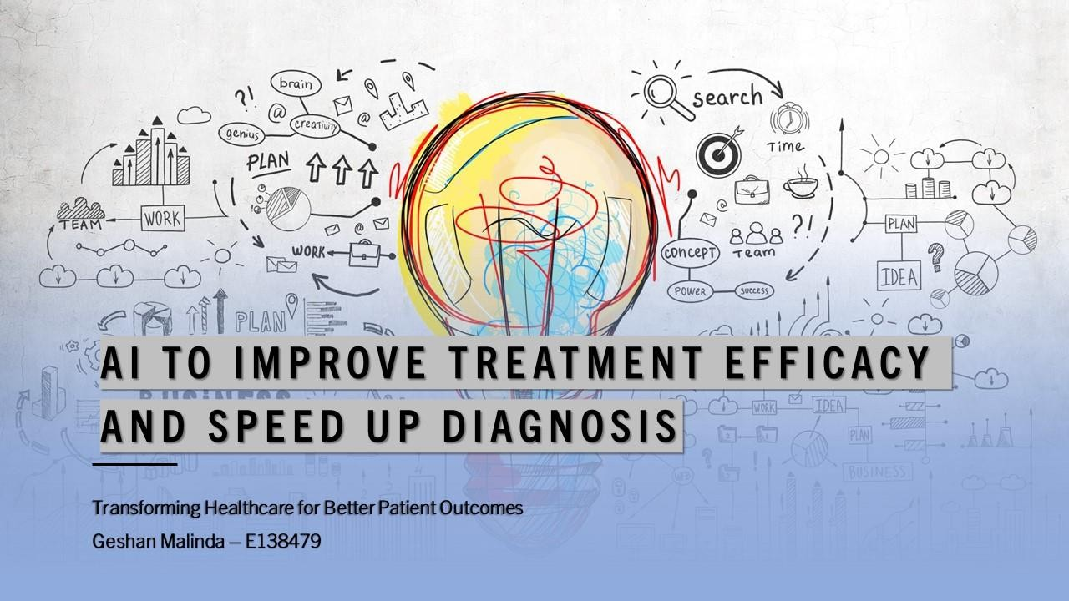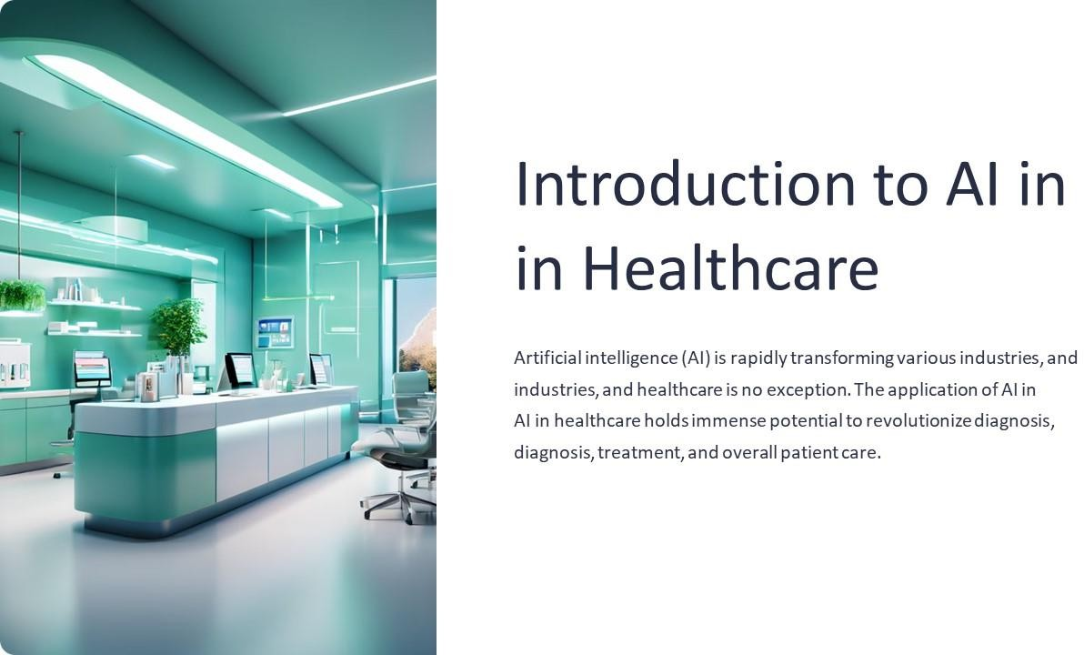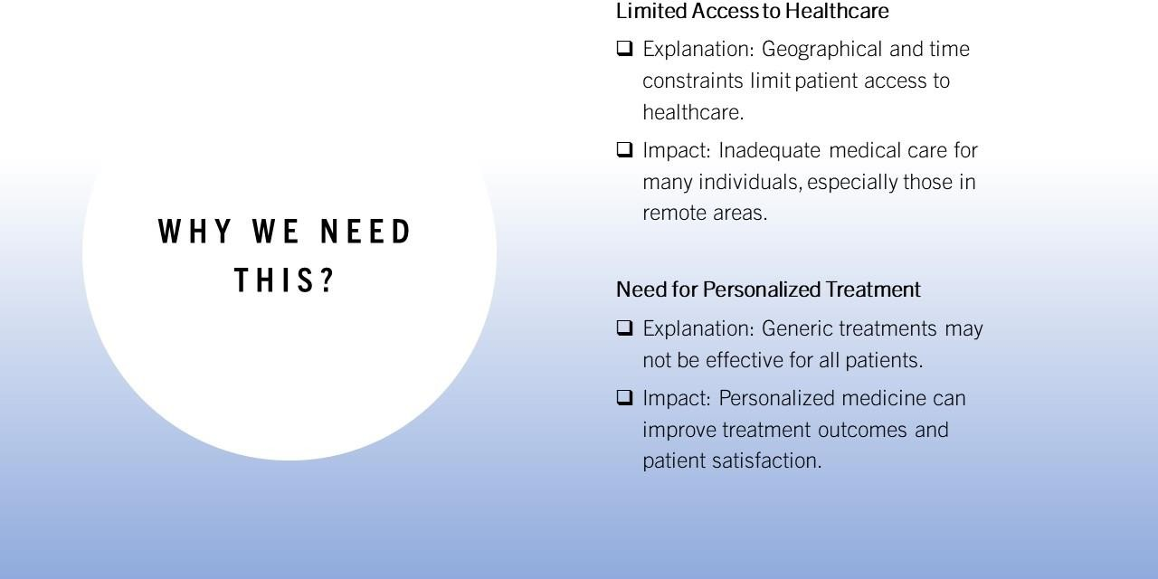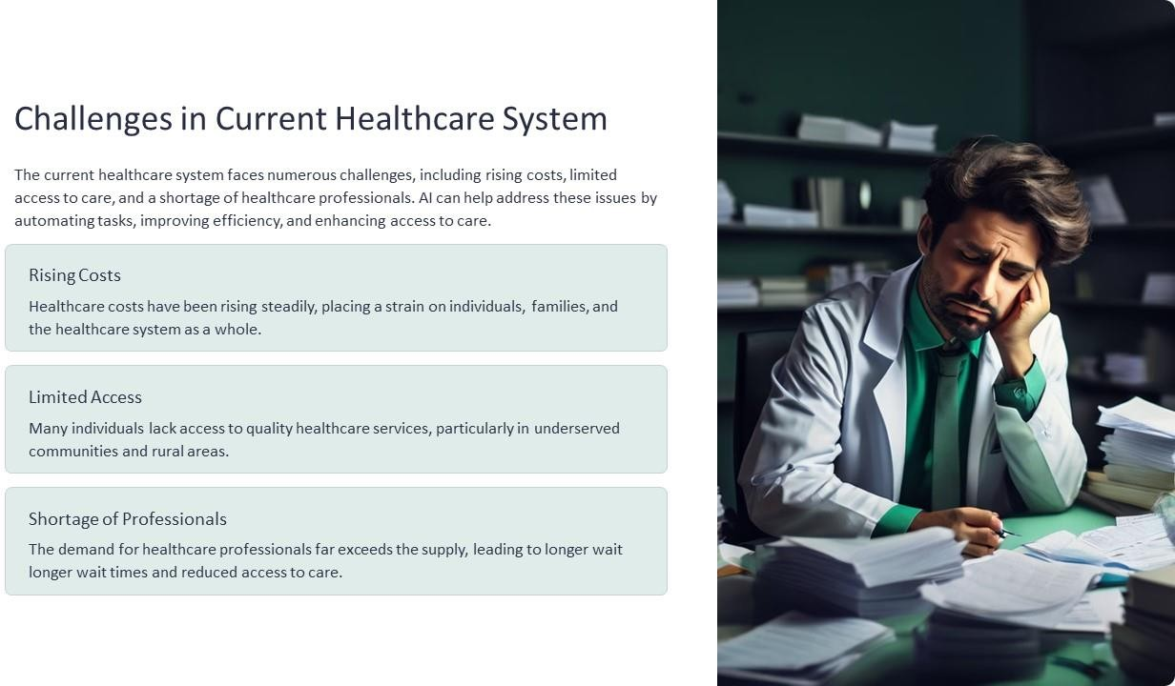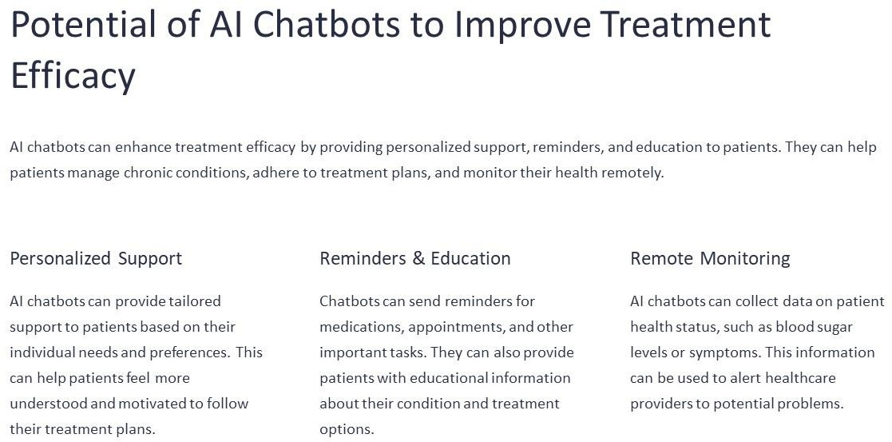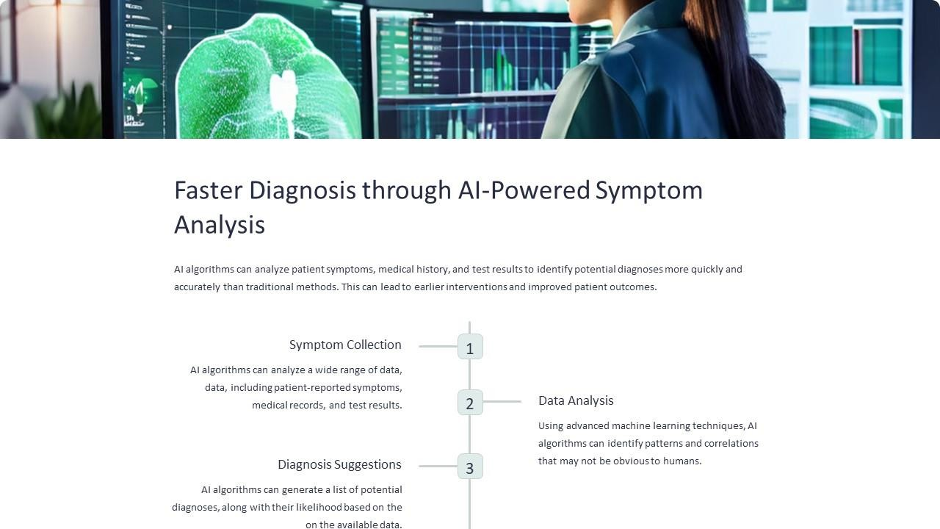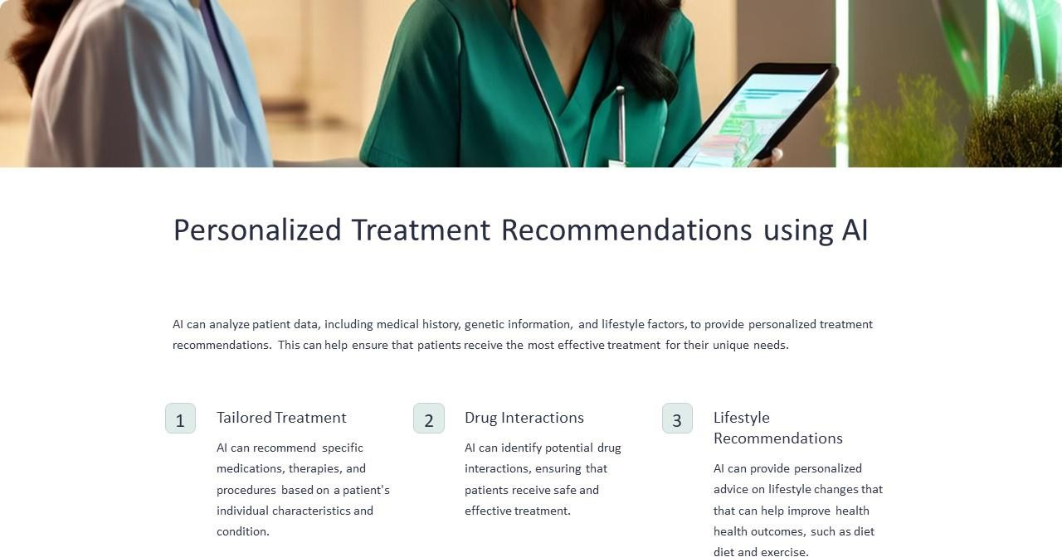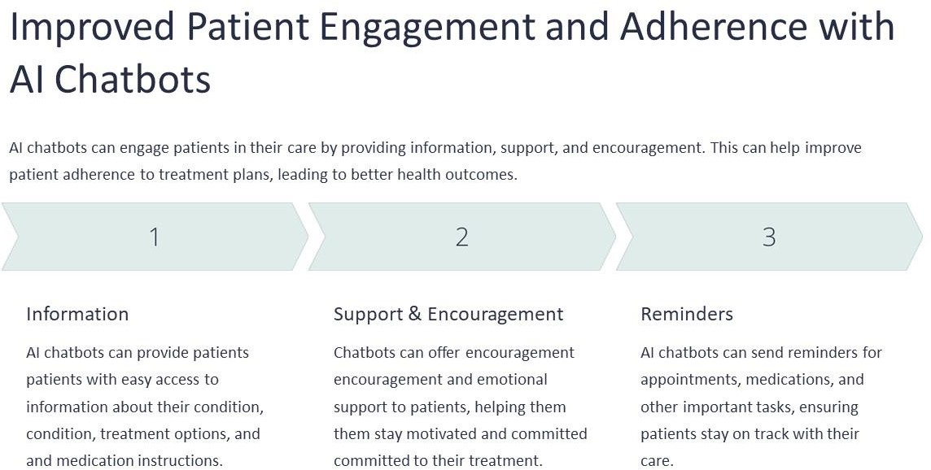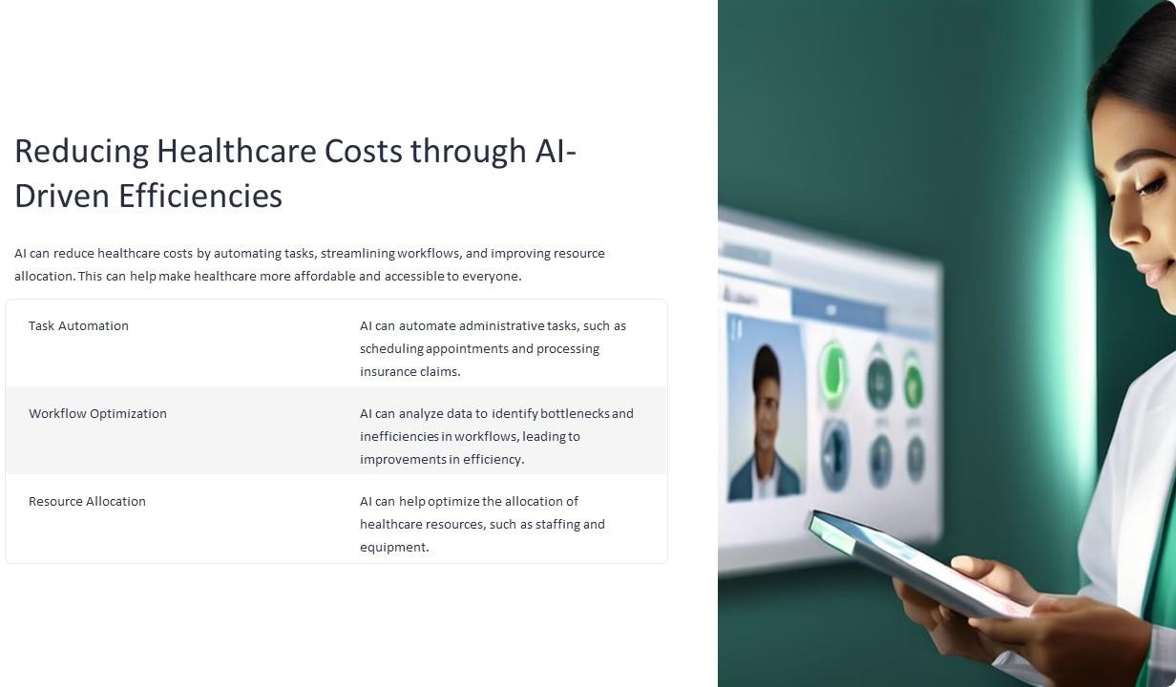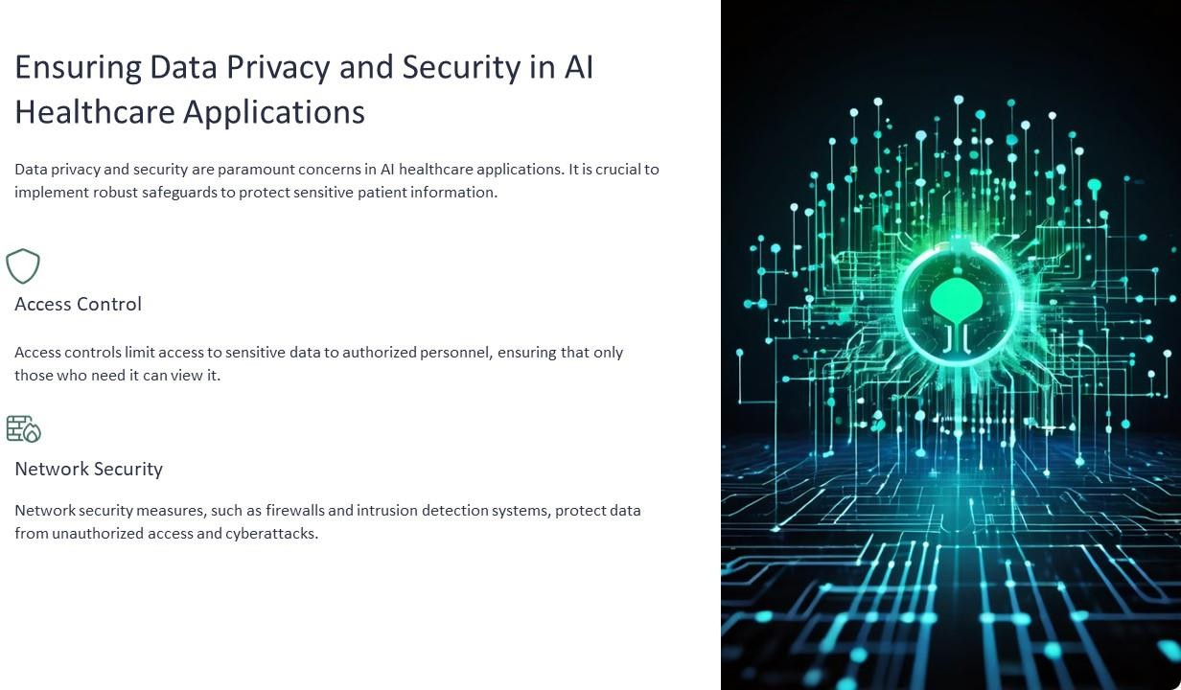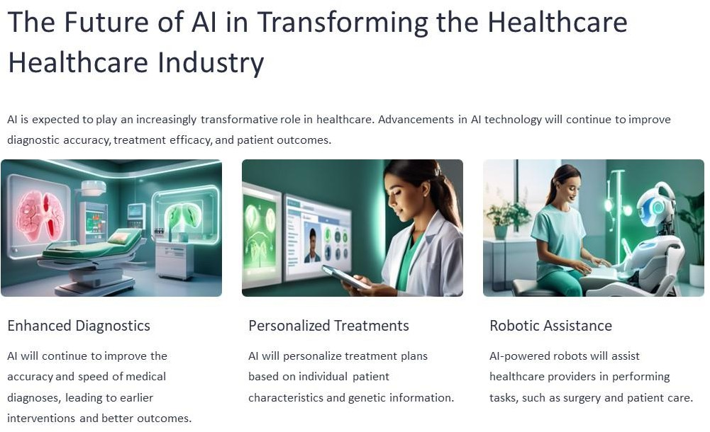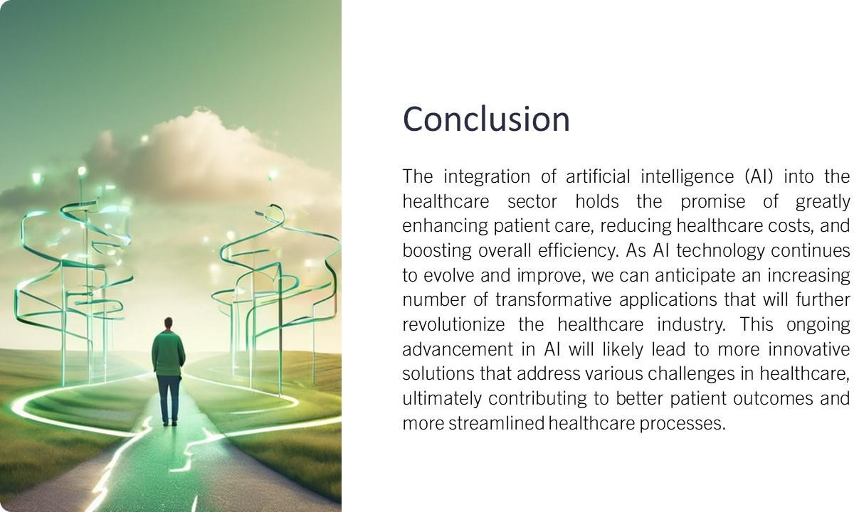

# Activity 03

## AI to improve treatment efficacy and speed up diagnosis

AI chatbots are causing a revolution in healthcare by offering continuous help and instant details key to patient care. Their capacity to automate routine tasks reduces expenses and boosts the efficiency of healthcare services. Engaging with patients , chatbots help with better adherence to treatments and enhance the overall healthcare experience. , their scalability and ability to operate in multiple languages make quality healthcare support more accessible to a wider audience.

### Providing a solution to people who are busy and haven’t time to take care of their health at the age of 20 to 45 years old.

The use of AI in healthcare systems is a major step to making medicine more personal and enhancing the care of patients. The development of a system to help people manage their health is a great effort. Such a system would offer medical advice and also maintain a record of one's health history, which is key for continuous health management.

The ability to keep and access personal health records when needed is a key trait ensuring that people can oversee their health data. The system's function to create reminders for taking medicine and the correct dosages is a vital resource for those dealing with ongoing illnesses or multiple medicines lowering the chance of forgetting doses or taking medicine.

Having a secure personal username and password provides another layer of protection for sensitive health data against unauthorized access. This is critical in a time when digital information can be breached. The AI chatbot's job in asking relevant health questions and giving reminders shows how AI can be used to create a more engaging and responsive healthcare experience.

This system marks a major progress in healthcare technology providing a more efficient, secure, and easy-to-use method to manage health. It shows how AI can improve life quality by giving support suited to personal health needs and schedules. As technology advances, we

expect to see more creative solutions like this made to satisfy the complicated needs of current healthcare and wellness.

## What do we expect from the Healthcare System and the AI Chatbot?

* **Symptom Checker:** Chatbots can ask patients a series of general questions to understand their symptoms and provide initial guidance or recommendations for medical advice.
* **Scheduling appointments:** Patients can schedule, reschedule, or cancel their appointment through the chatbot leading it towards a more efficient scheduling process
* **Medication Reminders:** Chatbots alert patients when they need to take their meds thus increasing medication adherence.
* **Health Monitoring:** In general, they can control the health variables and warn to give response or alerts based on patient inputs or connected devices.
* **Consumer Health Information:** Chatbots also will provide consumer health data, as to simple guidelines and training on account of the patients' precise fine repute and present-day situation.
* **Patient Records Access:** This includes things like patient records access which would allow patients to view their own health data and lab results by interacting with a chatbot.
* I**nsurance and Billing Queries:** Chatbots can help patients with their insurance- related queries, billing details as well as payment processes.
* **Mental Health Support:** One area where chatbots aid is mental health support. They can help by offering coping strategies, stress management techniques and resources for professional help.
* **Quick guide in emergencies:** Which the chatbot can help to calm down people while waiting for professional aid.
* **Post Consultation or Treatment Follow Up:** Chatbots can follow up with a patient and ensure them that they are doing good in case of any concerns.

## The advantage of using an AI based chatbot.

* **24/7 Availability**: AI chatbots give help all the time making sure patients can get healthcare information and support whenever they need it.
* **Instant Responses**: Chatbots manage many questions at once giving quick answers and cutting down waiting periods for patients.
* **Cost-Efficiency**: Using chatbots to do routine tasks can cut down on costs for healthcare providers.
* **Improved Patient Engagement**: Chatbots keep patients involved with reminders, follow-ups, and tailored talks helping them stick to their treatment plans.
* **Accessibility**: Chatbots help make healthcare information easier to get to for those in distant places or those who have trouble moving.
* **Data Collection and Analysis**: Chatbots can gather patient information during conversations offering important insights to help healthcare providers enhance care.
* **Scalability**: Chatbots can expand to manage more patient questions without needing extra human help.
* **Language Support**: Many AI chatbots provide support in multiple languages making healthcare services available to people who do not speak the native language.

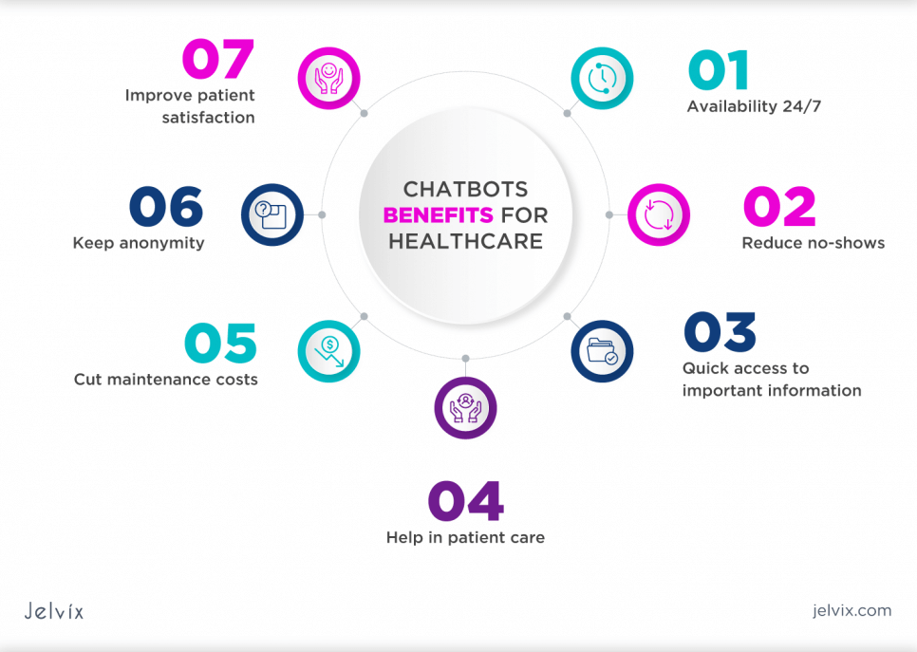

*Figure 7 Advantages of using AI chatbots in Heathcare.*

### Design an AI Chatbot to fulfill the requirements.

The system is web-based system. So, we created a login page to enter the system with a unique username and password for each user.

If someone new to the system they can register and gave their detail to the system by filling the create account form.

*Figure 8 Medical System Login*

*Figure 9 Medical System Register window*

After filling in the form user can click the signup button to enter the system. They can create a unique username and password for their own system.

*Figure 10 Medical System Chatbot*

In this window, users can chat with the chatbot about anything they need to know about their medicines and heath sympathies. You can ask bot to remind your appointments, set reminders to mention the times you have to get medicines, and you can ask about some sickness you feel often and get a recommendation to find what doctor or department you need to contact.

*Figure 11 Medical System Appointment window*

In this window users can book their appointments with doctors and get consultations. further information user can schedule appointments withing a large number of doctors, by selecting the days that they are available.

*Figure 12 Medical System wallet*

In this window users can enter their financial detail and pay online for their medical consultations. And users can add their insurance details and monitor the expenses and insurance amounts they are spending for medical reasons.

*Figure 13 Medical System Records*

In this window user can see their past appointments and the results of the doctors’ records about them. And the can always view their past records before and after meeting a doctor.

## Impact of AI on Healthcare for Patients Aged 20-45

###### User Group Current Situation (Before AI Solution)

Patients aged 20-45 often face several challenges in managing their healthcare needs:

1. **Limited Access to Healthcare**: Busy schedules and remote locations can make it difficult for young adults to visit healthcare providers regularly.
2. **Reactive Health Management**: Health monitoring often relies on periodic visits to doctors rather than continuous monitoring, leading to reactive rather than proactive health management.
3. **Slow and Inaccurate Diagnoses**: Traditional diagnostic processes can be slow and sometimes inaccurate, delaying treatment and increasing anxiety.
4. **Generic Health Recommendations**: Health advice is often generalized, lacking personalization that considers individual health data and lifestyle.

###### Working Practices (Before AI Solution)

1. **In-Person Consultations**: Patients typically rely on scheduling and attending in- person doctor appointments, which can be time-consuming and inconvenient.
2. **Manual Health Tracking**: Health metrics are often tracked manually or not at all, leading to less awareness of personal health status.
3. **Delayed Diagnostic Processes**: Diagnosis of conditions often requires multiple visits, tests, and waiting periods, slowing down the treatment process.
4. **General Health Advice**: Patients receive general health advice from doctors or online resources, which may not be tailored to their specific needs and conditions.

###### After the AI Solution: Outcome (Benefits and Changes)

1. Improved Access to Healthcare:
   * **Benefit**: AI-powered telemedicine platforms enable remote consultations, making healthcare more accessible for young, busy individuals.
   * **Example**: Apps like Babylon Health provide virtual consultations, reducing the need for physical visits and saving time.
2. Proactive Health Monitoring and Management:
   * **Benefit**: Wearable devices with AI capabilities continuously monitor health metrics, allowing individuals to manage their health proactively.
   * **Example**: Devices like Fitbit and Apple Watch use AI to provide real-time health data and personalized fitness recommendations.
3. Faster and More Accurate Diagnoses:
   * **Benefit**: AI’s ability to quickly and accurately diagnose health conditions leads to timely treatment and reduced anxiety.
   * **Example**: AI in dermatology apps like SkinVision helps users identify potential skin issues early, facilitating prompt medical intervention.
4. Personalized Health Recommendations:
   * **Benefit**: AI-driven apps offer personalized health and wellness advice based on individual data, promoting healthier lifestyles.
   * **Example**: AI nutrition apps like MyFitnessPal provide customized diet and exercise plans tailored to individual needs.

# Activity 04

## Ethical Impact from Emerging Technologies

### Environmental Pollution

The ethical effect of new technologies on the environment is a complex issue that needs to be considered. On one side cleantech advances like solar and wind energy provide sustainable choices to fossil fuels. These helps lessen climate change by cutting down greenhouse gas emissions. Such technologies are vital in moving to a greener economy and can cause a revolution in energy use patterns around the world. On the other side, the fast expansion of the Internet of Things (IoT) and Artificial Intelligence (AI) has led to a rise in production of electronic devices, which if not discarded, can lead to serious environmental pollution. The challenge is to develop and execute effective e-waste management strategies to ensure the advantages of these technologies do not harm the environment. It is crucial that policymakers, industry leaders, and consumers work together to enhance sustainable practices throughout the lifecycle of technological goods, from design to disposal, to reduce their ecological footprint.

### Social Behaviors

New tech AI-driven ones have changed how we interact. Social media connects people worldwide creating global groups and spreading info fast. But this same connectedness can make bad stuff like cyberbullying worse and make people feel alone when online chats replace face-to-face talks. Also, all the data shared online makes people worry about privacy and how society might be controlled. As these tools keep changing, it's super important for creators, rule-makers, and users to think about what's right and wrong. They need to balance the good stuff from new ideas with keeping people and society safe.

### Mental Health Ethics

Emerging technologies (ET) have a complex impact on mental health ethics. Mental health apps and teletherapy platforms make support more available and personal. But digital devices and AI-driven social media can harm mental health too. These tools aim to engage users but can cause addiction, worry, and sadness through bad content and likes-seeking. We must balance tech benefits with risks. Mental health tech should add to, not replace, in-person care. It needs to be safe high-quality, and fair for all. Data privacy is crucial too. Healthcare workers, tech makers, and lawmakers must team up. They should create rules and guides based on evidence to solve these tricky issues. This way, we can use ETs to help mental health in good ways. The tech world is changing fast so we need to keep an eye on how it affects our minds. It's not just about making cool new apps but making sure they help people without causing more problems. We should think about how these tools fit into our daily lives and if they're making us happier or just more stressed. It's a tough balance, but it's super important to get right for everyone's wellbeing.

### Physical Health

New health tech has a big influence on how we feel. Fitness trackers and AI health systems are changing how people look after themselves. These gadgets help folks stay active and spot health problems early. Users get info about what they do each day and how healthy they are. This helps them make smart choices about their wellness. But we need to think about the downsides too. Using too many digital devices can cause problems. People's eyes hurt from looking at screens for too long. Bad posture leads to body aches. Sitting around all day is risky for health. We need to find a balance when using new tech. The good stuff like easy health tracking is great, but we must watch out for the bad effects on our bodies. It's important to think about ethics when making and using new tech. We want it to help, not hurt, our overall physical health.

### Legal Implications and Human Rights

Emerging Technologies (ETs) have a complex ethical impact. This impact affects many parts of society. It includes legal issues and human rights worries. ETs grow fast. They often move past current laws. This creates a gap in rules. This gap can cause big problems. For instance, self-driving cars use AI. This means we need to rethink safety rules and who's to blame in crashes. We must do this to keep public trust. We also need to do this to make sure we use these technologies. The quick growth of ETs has an influence on how we make and apply laws. We need to look at how these new technologies affect our rights. We should think about how to protect people while still letting tech advance. It's important to find a balance between innovation and safety. We must consider the long-term effects of these technologies on society. This is key to make sure ETs benefit everyone, not just a few.

Blockchain technology opens up fresh possibilities for transactions and managing assets in finance. Yet it also brings new challenges in stopping fraud and protecting consumers. Regulators must come up with innovative ways to keep users safe while encouraging progress. Finding the right balance between rules and tech advances is tricky. Too many strict regulations might slow growth, but loose policies could allow exploitation and instability in the financial world. It's crucial to strike a good balance that allows for innovation without compromising security. The financial sector needs to adapt to these changes while ensuring that the interests of all stakeholders are protected. As blockchain continues to evolve so must the approaches to regulating it .

ETs affect human rights just as much. AI-driven surveillance tech boosts security for the big time, but it also worries people about privacy and governments going too far. Using ETs is super important to guard personal freedoms and stop privacy from disappearing. We need to set up clear ethics rules and strong watchdogs to make sure ETs help the public and don't turn into ways to control people. It's crucial to keep an eye on how these technologies are used to protect our rights and freedoms. The balance between safety and privacy is tricky, but it's a must-have conversation in our tech-filled world. We can't ignore the power of ETs, but we got to use them to avoid any nasty surprises down the road.

Emerging Technologies (ETs) create a complex ethical landscape that needs worldwide teamwork. As ETs grow, we must set up legal and ethical rules. These rules should keep up with tech progress and protect human rights. ETs can guard or break these rights, so we need

to use them. Our shared future depends on how we guide these techs. We should aim to boost human dignity and freedom. This way, ETs can help us move forward and gain power. [Min, Alfonso. (2023). HUMAN RIGHTS AND EMERGING TECHNOLOGIES. 10.13140/RG.2.2.31834.72648.]

### Cultural Impact

AI and VR are game changers for preserving culture and teaching people about it. They let us make virtual museums and cool interactive stuff that can show off historical objects and traditions to folks all over the world. This helps people get a better grasp on different cultures and appreciate them more. AI can translate old writings or recreate events from the past, while VR lets you experience cultural places and practices from your couch. But there's a real worry that these technologies might make cultures too similar. As more people get their hands on technology, there's a chance that big cultures could overshadow local ones, and we could lose unique cultural identities and ways of doing things. It's super important for the people making and using these technologies to think about these effects and try to find a balance. We want to promote cultural exchange without messing up the world's rich cultural tapestry. When we bring these new technologies into cultural stuff, we need to be guided by ethics to make sure they're tools for preservation and not things that erode culture.

### Religious Beliefs

Technology and religion intertwine creating a mix of problems and chances. AI and other tech advancements can spark deep ethical debates that touch on key beliefs of different faiths. For example, AI in medicine might start arguments about when life begins and ends, what makes us conscious, and how much control we have versus God's plan. But tech also opens new doors for faith. People can now join online churches and pray together helping believers worldwide feel connected. This shows we need tech experts, ethics pros, and religious big shots to keep talking as things change so we handle it all with care and respect.

## Challenges and Problems When Introducing New Emerging Technologies.

* People Worry About Using New Stuff/ Fear of New Technology Adoption

People often don't like new tech because they're scared of what they don't know and think they might lose their jobs. Take AI at work - it makes people nervous about getting replaced and having to learn new things.

* Unexpected Things Happen

New tech can cause surprises we didn't plan for. Like self-driving cars - they might make roads safer, but they could also break down or get hacked. We need to test them a lot and make rules to keep everyone safe.

* Still Figuring It Out

A lot of new techs is still being tested so we don't know what'll happen when we use it. Quantum computers could be super powerful, but right now they're just experiments. It's hard to guess what good or bad stuff they might do.

* Investment Hesitancy

Investors often shy away from putting money into emerging tech because it costs a lot upfront and they're not sure if they'll make money. This happens a lot with big new ideas like nuclear fusion where you have to spend tons of cash but won't see any profit for ages.

* Lack of Proper Platforms

Many times, there's no good way to show off and try out new tech. Like, if you're a tiny startup, you might not have the stuff or people you need to get your cool idea out there for folks to buy.

* No Proper Guarantee

New tech is always a gamble. You can't be sure it'll work out. Just look at all the tech startups that fail. Lots of great ideas never make it to stores because stuff goes wrong that nobody saw coming.

## How to Keep Up with Emerging Technologies

### Get Patents

* Companies grab patents to guard their new ideas and stay ahead of rivals. This move also draws in investors by showing off their creative chops and money-making potential.

### Show Off on TV Invention Programs

* Putting new gadgets on TV and other media gets people talking and interested. This can bring in customers and folks with cash to invest. Shows like "Shark Tank" have helped fund and launch lots of cool new stuff.

### Use Social Media to Spread the Word

* Social media marketing is cheap and reaches tons of people. Twitter, LinkedIn, and Instagram work great to hype up new tech, chat with users, and build a fan base around your cool invention.

## Technology Adoption Process.

People and businesses need to grasp how new tech gets adopted. It's a journey that kicks off with just knowing about the tech and wraps up when it's part of everyday life. The Technology Adoption Curve model shows how different folks jump on the tech bandwagon. Innovators love to try new stuff first. Early Adopters play a big role in making the tech catch on. The Early Majority take their sweet time but hop on when they see others using it . The Late Majority are skeptical and hang back until loads of people are using it. Laggards are the last to join often when they have no choice. This info helps companies roll out new tech in a way that more people will use.

Companies can get the Early Majority to use new tech by showing it works well. They do this with success stories and case studies. They need to give clear examples of how the tech has made things better for other users in the same field. They should also offer good support and training to help with worries about how hard the new tech might be. Companies should use Early Adopters to help. These people can share their good experiences and influence others, making a community for the new tech can help. Here, users can share tips, ask questions, and see how others are using it. This can motivate the Early Majority to give it a try.

The Early Majority needs proof that new tech is reliable. Success stories and case studies have an influence on their decision. Companies must provide real-world examples of how the tech has improved things for others in their industry. Good support and training has an impact on easing fears about complex tech. Early Adopters play a key role too. They act as tech ambassadors sharing their experiences and swaying their peers. Building a tech community is also crucial. It lets users exchange ideas, get help, and see the benefits others are getting. This community feel can push the Early Majority to take the plunge into new tech. (Altadonna, 2020)

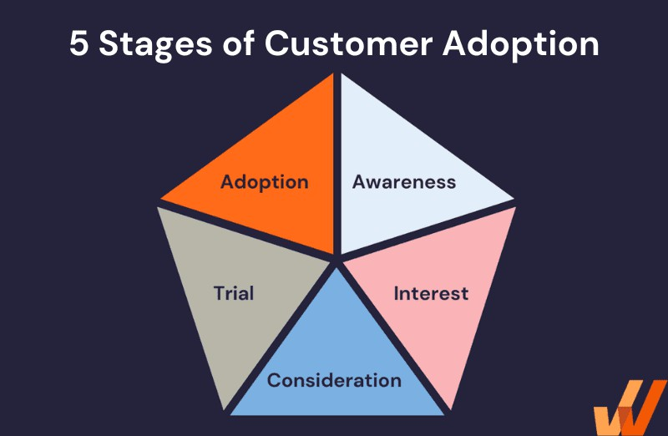

*Figure 30 5 stages of customer adoption*

### Technology Adoption Process

* Awareness: Users become aware of the new technology.
* Interest: Users show interest and seek more information.
* Evaluation: Users evaluate the technology’s benefits and drawbacks.
* Trial: Users try the technology on a small scale.
* Adoption: Users decide to fully adopt and integrate the technology into their routine.

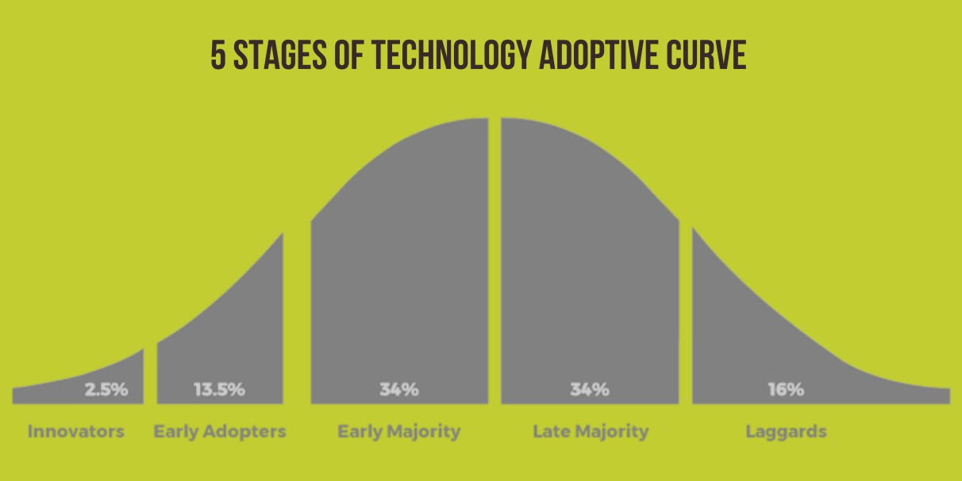

*Figure 31 Technology adoption curve*

# Conclusion

The advent of new technology indeed indicates transformative changes, offering remarkable benefits like improved quality of life and economic growth. However, it also introduces complex challenges that necessitate careful navigation. Legislation must evolve to safeguard privacy and intellectual property without stifling innovation, ensuring a harmonious progression of society and technology. Ethical considerations are paramount; it is crucial that technological advancements promote inclusivity and fairness, with corporate transparency and accountability being non-negotiable. Addressing societal disparities in tech access and providing support for those displaced by automation through retraining initiatives is essential for a cohesive transition. Economically, it is vital to bolster small businesses, enabling them to thrive amidst rapid technological shifts. By striking a prudent balance that embraces technological advancements while conscientiously addressing their implications, we can foster a sustainable and equitable tech ecosystem. Collaborative efforts between governments, corporations, and community entities are key to constructing a resilient technological infrastructure that benefits all members of society.

# Reference list

Altadonna, N. (2020). *Technology Adoption Explained*. [online] Apty. Available at: https:/[/www.apty.io/blog/technology-adoption-explained/](http://www.apty.io/blog/technology-adoption-explained/) [Accessed 6 Jul. 2024].

Duggal, N. (2019). *8 Top Technology Trends for 2019 and the Jobs They’ll Create*. [online] Simplilearn.com. Available at: https:/[/www.simplilearn.com/top-technology-trends-and-jobs-](http://www.simplilearn.com/top-technology-trends-and-jobs-) article [Accessed 22 Jun. 2024].

Ellis, S. (n.d.). *Emerging Technology Trends You Need to Know in 2021*. [online] [www.office1.com.](http://www.office1.com/) Available at: https:/[/www.office1.com/blog/emerging-technology-trends-](http://www.office1.com/blog/emerging-technology-trends-) you-need-to-know [Accessed 22 Jun. 2024].

Halaweh, M. (2013). Emerging Technology: What Is it? *Journal of Technology Management & Innovation*, [online] 8(3), pp.19–20. doi:https://doi.org/10.4067/s0718- 27242013000400010.

Insights, S. (2023). *10 Emerging Technologies: How Tech Trends Shape 40+ Industries*. [online] StartUs Insights. Available at: https:/[/www.startus-insights.com/innovators-](http://www.startus-insights.com/innovators-) guide/emerging-technologies-full-guide/ [Accessed 22 Jun. 2024].

ISACA. (n.d.). *Eight Overlooked Emerging Tech Risks and How to Mitigate Them*. [online] Available at: https:/[/www.isaca.org/resources/news-and-](http://www.isaca.org/resources/news-and-) trends/newsletters/atisaca/2024/volume-9/eight-overlooked-emerging-tech-risks-and-how-to- mitigate-them#:~:text=Managing%20large%20volumes%20of%20data [Accessed 22 Jun.

2024].

KnowMadMood. (2023). *Which Industries Have Been the Most Impacted by AI?* [online] Available at: https:/[/www.knowmadmood.com/en/blog/which-industries-have-been-the-most-](http://www.knowmadmood.com/en/blog/which-industries-have-been-the-most-) impacted-by-ai/ [Accessed 1 Jul. 2024].

MIT Technology Review (2024). *10 Breakthrough Technologies 2024*. [online] MIT Technology Review. Available at: https:/[/www.technologyreview.com/2024/01/08/1085094/10-breakthrough-technologies-](http://www.technologyreview.com/2024/01/08/1085094/10-breakthrough-technologies-) 2024/ [Accessed 22 Jun. 2024].

Monastyrska, K. (2024). *Chatbots in Healthcare Industry: Features and Benefits*. [online] DICEUS. Available at: https://diceus.com/chatbots-in-healthcare/ [Accessed 2 Jul. 2024].

NEW AND EMERGING DIGITAL TECHNOLOGIES AND HUMAN RIGHTS. (n.d.).

Available at: https:/[/www.ohchr.org/sites/default/files/documents/issues/digitalage/cfis/tech-](http://www.ohchr.org/sites/default/files/documents/issues/digitalage/cfis/tech-) standards/subm-standard-setting-digital-space-new-technologies-nhris-qatar-nrhi-1-input- part-1.pdf.

Salminen, M. (2023). *The 5 Stages of Technology Adoption | ClickLearn*. [online] ClickLearn. Available at: https:/[/www.clicklearn.com/blog/5-stages-of-technology-adoption/](http://www.clicklearn.com/blog/5-stages-of-technology-adoption/) [Accessed 6 Jul. 2024].

Satardekar, S. (n.d.). *Healthcare Chatbots - Benefits and Use Cases*. [online] Yellow.ai. Available at: https://yellow.ai/blog/healthcare-chatbot/ [Accessed 2 Jul. 2024].

Taylor, P. (2022). *The Risks of Implementing Emerging Technology*. [online] The Risk Coalition. Available at: https:/[/www.riskcoalition.org.uk/blog-posts/the-risks-of-](http://www.riskcoalition.org.uk/blog-posts/the-risks-of-) implementing-emerging-technology [Accessed 22 Jun. 2024].

Winston & Strawn (2023). *What Is the Definition of Emerging Technology? | Winston & Strawn Legal Glossary*. [online] Winston & Strawn - What Is the Definition of Emerging Technology? | Winston & Strawn Legal Glossary. Available at: https:/[/www.winston.com/en/legal-glossary/emerging-technology](http://www.winston.com/en/legal-glossary/emerging-technology) [Accessed 22 Jun. 2024].

World Economic Forum. (n.d.). *These Are the Top 10 Emerging Technologies of 2021*. [online] Available at: https:/[/www.weforum.org/agenda/2021/11/these-are-the-top-10-](http://www.weforum.org/agenda/2021/11/these-are-the-top-10-) emerging-technologies-of-2021/ [Accessed 22 Jun. 2024].